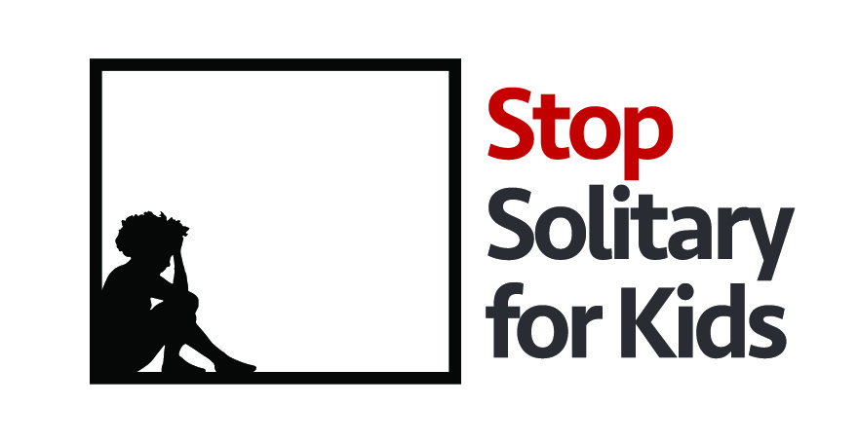

National Council of Juvenile and Family Court Judges’ Restricts Isolation of Youth
Stop Solitary for Kids strongly supports this standard, and urges others to adopt the same strategy

The Stop Solitary for Kids campaign and its partner organizations – the Center for Children’s Law and Policy, the Council of Juvenile Correctional Administrators, the Justice Policy Institute, and the Center on Juvenile Justice Reform at Georgetown University – strongly support the National Council of Juvenile and Family Court Judges’ (NCJFCJ) for its resolution on solitary confinement for young people. NCJFCJ’s resolution restricts isolation to situations when a youth is out of control and poses an immediate risk of harm to self or others, and then only until the youth regains control. This is the same standard that the Stop Solitary for Kids campaign urges cities, counties and states to adopt. It is critically important that NCJFCJ recognized the crucial role of the nation’s juvenile and family court judges in ending this dangerous and counterproductive practice. The Stop Solitary for Kids campaign looks forward to partnering with NCJFCJ to implement strategies to end the solitary confinement of youth in this country.

The Stop Solitary for Kids campaign is a national effort to end solitary confinement for youth through policy reform, legislative education, training, and technical assistance. For more information about the Stop Solitary for Kids campaign, please visit stopsolitaryforkids.org or contact Campaign Manager Jennifer Lutz at (202) 637.0377 ext. 106 or jlutz@cclp.org.
#StopSolitaryforKids | stopsolitaryforkids.org

